**DSA Assignment – 19th June**

**Name – Karan Joshi**

**Roll No. – 23/11/EC/036**

**Leetcode Id – Karan_Joshi068048**

**Geeksforgeeks Id – wwwjoshikaran3424**

**Github Repo Link -** [**https://github.com/KaranJoshi101/urban-octo-robot/**](https://github.com/KaranJoshi101/urban-octo-robot/)

DSA-Section -

Question 1: Find the Town Judge

Platform: LeetCode

Problem Link: <https://leetcode.com/problems/find-the-town-judge/>

Submission Screenshot:

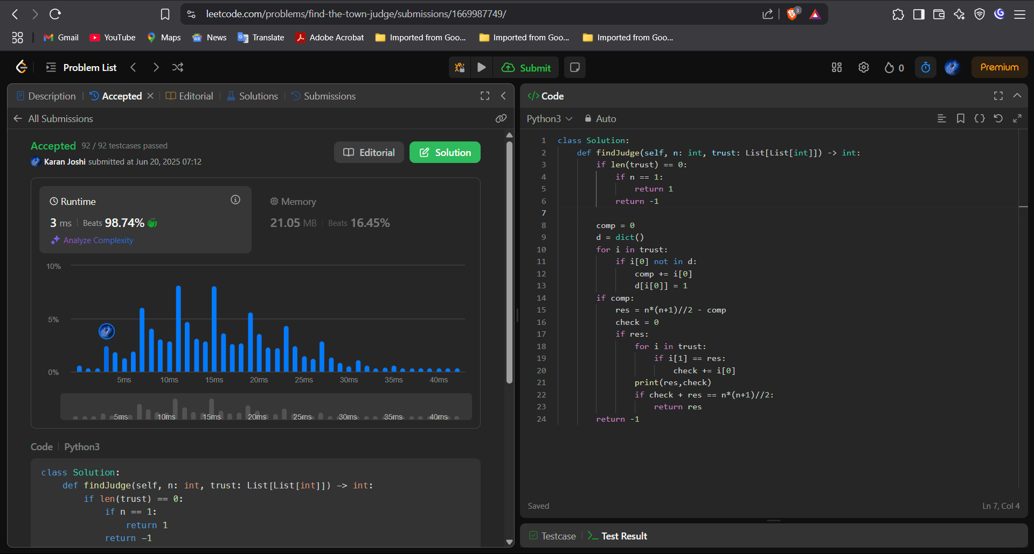

Question 2: Plus One

Platform: LeetCode

Problem Link: <https://leetcode.com/problems/plus-one/description/>

Submission Screenshot:

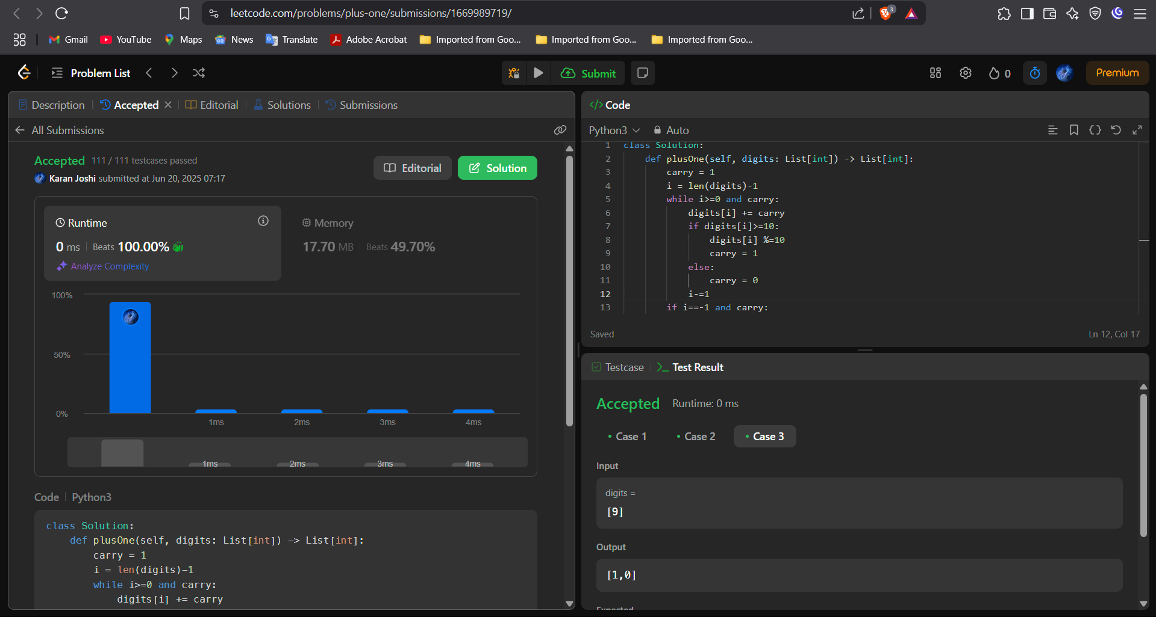

Question 3: Maximum Subarray

Platform: LeetCode

Problem Link: <https://leetcode.com/problems/maximum-subarray/description/>

Submission Screenshot:

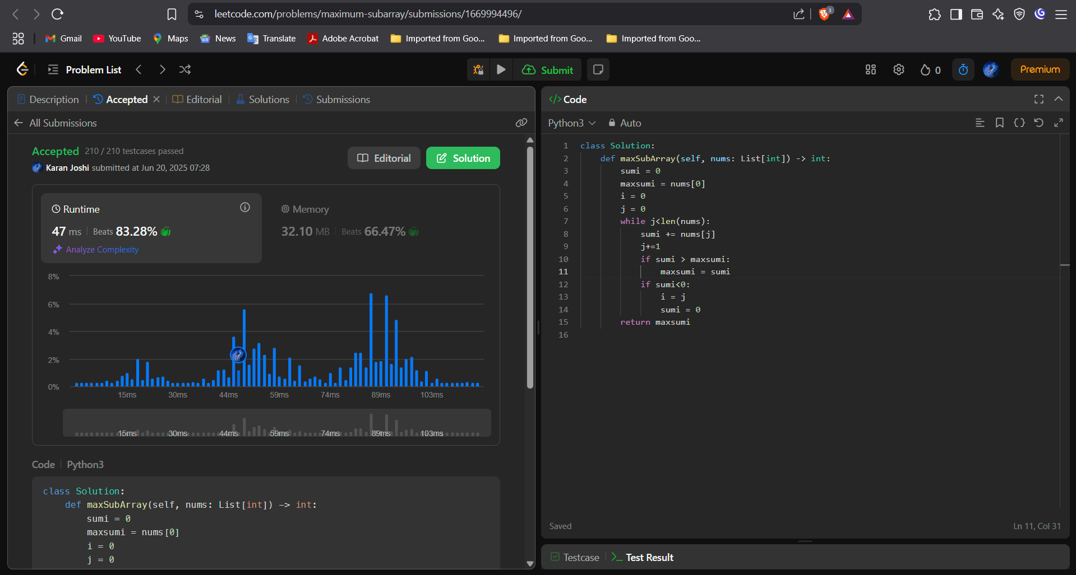



Question 4: Assign Cookies

Platform: LeetCode

Problem Link: <https://leetcode.com/problems/assign-cookies/description/>

Submission Screenshot:

